

International School

**Capstone Project 2**

CMU-SE 451

**Project Proposal**

**Version 2.0**

**Date: 06/04/2021**

**ViVu - The smart travel system supports with chatbot and short video social network**

**Submitted by**



**Approved by Nguyen Duc Man**

**Proposal Review Panel Representative:**

Name Signature Date

**Capstone Project 2- Mentor:**

Name Signature Date

# 

**PROJECT INFORMATION**

|  |  |  |  |
| --- | --- | --- | --- |
| **Project acronym** | ViVu | | |
| **Project Title** | The smart travel system supports chatbot and integrates short video social network | | |
| **Start Date** | 22 Feb 2021 | **End Date** | 30 May 2021 |
| **Lead Institution** | International School, Duy Tan University | | |
| **Project Mentor** | Man, Nguyen Duc, Ph.D | | |
| **Scrum master**  **/ Project Leader & contact details** | Sang, Nguyen Thanh  Ema[il: thanhsang3111999.ntb@gmail.com](mailto:thanhsang3111999.ntb@gmail.com) Tel: 0344684069  ID: 23211212363 | | |
| **Partner Organization** |  | | |
| **Project Web URL** |  | | |
| **Team members** | Name | Email | Tel |
| 2321121321 | Tuan, Doan Kim | [doantuan21101999@gmail.com](mailto:doantuan21101999@gmail.com) | 0913622928 |
| 2321124963 | Loc, Phung Hoang Phu | [phunghoangphuloc@gmail.com](mailto:phunghoangphuloc@gmail.com) | 0912698173 |
| 2321125061 | Thuyen, Pham Van | [phamvanthuyen2802@gmail.com](mailto:phamvanthuyen2802@gmail.com) | 0795697332 |

**REVISION HISTORY**

|  |  |  |  |  |
| --- | --- | --- | --- | --- |
| **Version** | **Date** | **Comments** | **Author** | **Approval** |
| 1.0 | 04/9/2020 | Create Database Design | All members |  |
| 1.1 | 10/9/2020 | Update Database Design 2. | All members |  |
| 2.0 | 06/04/2021 | Update Version 2 | All members |  |

**TABLE OF CONTENT**

**Project Information** 0

**Database Design Document** 1

**Document Approvals** 2

**1.** **Introduction** 4

**1.1.** **Purpose** 4

**1.2.** **Goal** 4

**1.3.** **Scope** 4

**1.4.** **Data storage platforms** 5

**1.5.** **Definition, Acronyms and Abbreviations** 5

**2.** **Database Design** 6

**2.1.** **Table Overview** 6

**2.2.** **Entity Relationship Diagram** 7

**2.3.** **Table Relationship Diagram** 7

**2.4.** **Detail** 8

**2.4.1.** **voucher** 8

**2.4.2.** **voucher_user** 9

**2.4.3.** **users** 9

**2.4.4.** **roles** 9

**2.4.5.** **tourist** 9

**2.4.6.** **booked_tour** 10

**2.4.7.** **tour** 10

**2.4.8.** **tourist_attractions** 11

**2.4.9.** **tour_detail** 11

**2.4.10.** **tour_promotion** 11

**2.4.11.** **Promotion** 12

**2.4.12.** **Review** 12

**2.4.13.** **Interact** 12

**2.4.14.** **Interact Comment** 13

**2.4.15.** **Interact Post** 13

**2.4.16.** **Post** 13

**2.4.17.** **Post Comment** 13

**2.4.18.** **Post Status** 14

**2.4.19.** **Privacy** 14

**2.4.20.** **User Following** 14

**3.** **References** 15

1. **Introduction**
   1. **Purpose**

Place information system’s database design document describes structure of database and file structure of system. Database Design document will introduce all attribute the System that will help developer and tester base on this design to implement and test.

* 1. **Goal**

To create database tables most accurate.

* 1. **Scope**

This Database Design Document provides the basic for “viBOTour” Database design.

It describes both logical and physical definition, non-functional issues, and the database interfaces; storage aspects are defined in the physical database design sections.

The tables performance considerations requirements. The following topics are covered in this document:

* Assumptions and decisions on database design.
* Entity-mapping.
* Table column definitions.
* Primary, unique and foreign key definitions.
* Column and row level validation rules (check constraints).
* Rule for populating specific columns (sequences, derivations, demoralized (column)).
* Interfaces and dependencies with other components.
* Data access description.

The database design for “Demark – Decentralized Market” is composed of definitions for database objects derived by mapping entities to tables attributes to columns, unique identifiers to unique keys and relationship to foreign keys.

During design, these initial definitions are enhanced to support the functionality described in the functional specification/ user stories and defined in the primary and supporting modules of the application high level design.

* 1. **Data storage platforms**

- Data of application is stored in PostgreSQL database

- In PostgreSQL, data structure is stored as tables that the database objects that behave as containers for the data, in which the data will be logically organized in rows and columns format.

* 1. **Definition, Acronyms and Abbreviations**

|  |  |  |
| --- | --- | --- |
| **Abbreviations** | **Description** | **Comment** |
| PK/FK | Primary/ Foreign Key | Use to indicate a file is a Primary or Foreign key in a table |
| ERD | Entity Relationship Diagram | Show the relationship between entities in the system |
|  |  |  |

1. **Database Design**

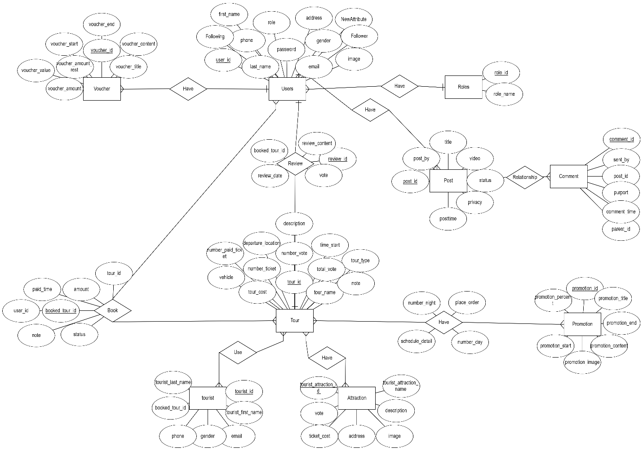

* 1. **Table Overview**

|  |  |  |
| --- | --- | --- |
| **No.** | **Table name** | **Short Description** |
| 1 | Voucher | This table shows all information of Voucher |
| 2 | Voucher_User | This junction table connect table Voucher with User |
| 3 | Users | This table shows all information of User |
| 4 | Roles | This table shows all information of Roles |
| 5 | Tourist | This table shows all information of Tourist who join the tour |
| 6 | Booked_tour | This table shows all information of the tour which is booked by user |
| 7 | Tour | This table shows all information of Tour |
| 8 | Tourist_attractions | This table shows all information of Tourist Attractions |
| 9 | Tour_detail | This junction table shows detail all information of Tour, connect table Tour with Tourist Attractions |
| 10 | Tour_promotion | This junction table connect table Tour with Promotion |
| 11 | Promotion | This table shows all information of Promotion |
| 12 | Review | This table shows all information of Review for Tour which is reviewed from Tourist |
| 13 | Interact | This table shows all type of Interact |
| 14 | Interact_comment | This table shows all type of Interact of Comment |
| 15 | Interact_post | This table shows all type of Interact of Post |
| 16 | Post | This table shows all information of Post |
| 17 | Post_comment | This table shows all Comment of Post |
| 18 | Post_status | This table shows all Status of Post |
| 19 | Privacy | This table shows all Privacy of Post |
| 20 | User Following | This table shows all information of user follow |

* 1. **Entity Relationship Diagram**
  2. **Table Relationship Diagram**

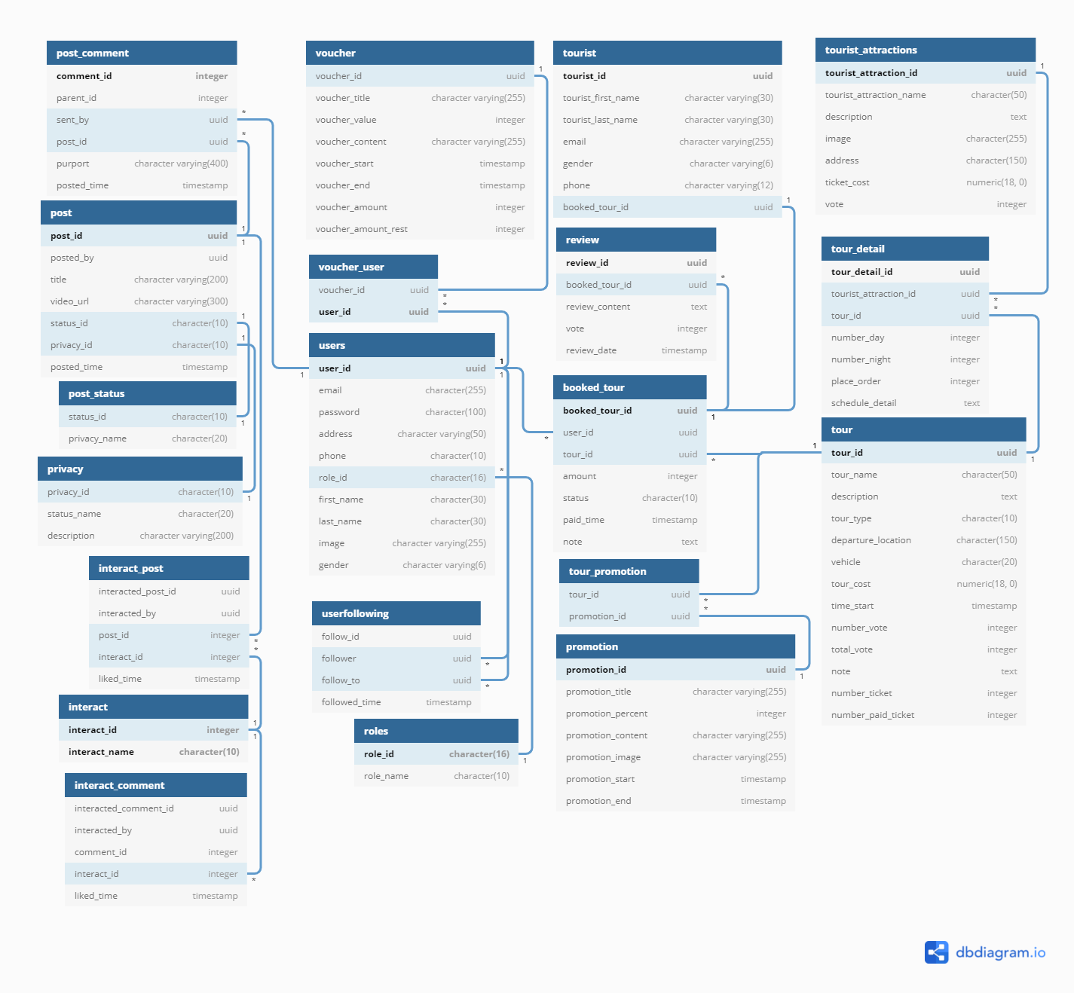

* 1. **Detail**
     1. **voucher**

|  |  |  |  |  |  |
| --- | --- | --- | --- | --- | --- |
| **Attributes** | **Datatype** | **Null** | **Key** | **Default** | **Extra** |
| voucher_id | uuid | Not | PK | uuid_generate_v4() |  |
| voucher_title | character varying(255) |  |  |  |  |
| voucher_value | integer |  |  |  |  |
| voucher_content | character varying(255) |  |  |  |  |
| voucher_start | timestamp |  |  |  |  |
| voucher_end | timestamp |  |  |  |  |
| voucher_amount | integer |  |  |  |  |
| voucher_amount_rest | integer |  |  |  |  |
|  |  |  |  |  |  |

* + 1. **voucher_user**

|  |  |  |  |  |  |
| --- | --- | --- | --- | --- | --- |
| **Attributes** | **Datatype** | **Null** | **Key** | **Default** | **Extra** |
| voucher_id | uuid | Not | FK, PK | uuid_generate_v4() |  |
| user_id | uuid | Not | FK, PK | uuid_generate_v4() |  |
|  |  |  |  |  |  |

* + 1. **users**

|  |  |  |  |  |  |
| --- | --- | --- | --- | --- | --- |
| **Attributes** | **Datatype** | **Null** | **Key** | **Default** | **Extra** |
| user_id | uuid | Not | PK, FK | uuid_generate_v4() |  |
| email | character(255) |  |  |  |  |
| Password | character(100) |  |  |  |  |
| address | character varying(50) |  |  |  |  |
| phone | character(10) |  |  |  |  |
| role_id | character(16) | Not | FK |  |  |
| first_name | character(30) |  |  |  |  |
| last_name | character(30) |  |  |  |  |
| image | character varying(255) |  |  |  |  |
| gender | character varying(6) |  |  |  |  |
|  |  |  |  |  |  |

* + 1. **roles**

|  |  |  |  |  |  |
| --- | --- | --- | --- | --- | --- |
| **Attributes** | **Datatype** | **Null** | **Key** | **Default** | **Extra** |
| role_id | character(16) | Not | PK |  |  |
| role_name | character(10) |  |  |  |  |
|  |  |  |  |  |  |

* + 1. **tourist**

|  |  |  |  |  |  |
| --- | --- | --- | --- | --- | --- |
| **Attributes** | **Datatype** | **Null** | **Key** | **Default** | **Extra** |
| tourist_id | uuid | Not | PK | uuid_generate_v4() |  |
| tourist_first_name | character varying(30) |  |  |  |  |
| tourist_last_name | character varying(30) |  |  |  |  |
| email | character varying(255) |  |  |  |  |
| gender | character varying(6) |  |  |  |  |
| phone | character varying(12) |  |  |  |  |
| booked_tour_id | uuid | Not | FK | uuid_generate_v4() |  |
|  |  |  |  |  |  |

* + 1. **booked_tour**

|  |  |  |  |  |  |
| --- | --- | --- | --- | --- | --- |
| **Attributes** | **Datatype** | **Null** | **Key** | **Default** | **Extra** |
| booked_tour_id | uuid | Not | PK | uuid_generate_v4() |  |
| user_id | uuid | Not | FK | uuid_generate_v4() |  |
| tour_id | uuid | Not | FK | uuid_generate_v4() |  |
| amount | integer |  |  |  |  |
| status | character(10) |  |  |  |  |
| paid_time | timestamp |  |  |  |  |
| note | text |  |  |  |  |
|  |  |  |  |  |  |

* + 1. **tour**

|  |  |  |  |  |  |
| --- | --- | --- | --- | --- | --- |
| **Attributes** | **Datatype** | **Null** | **Key** | **Default** | **Extra** |
| tour_id | uuid | Not | PK | uuid_generate_v4() |  |
| tour_name | character(50) |  |  |  |  |
| description | text |  |  |  |  |
| tour_type | character(10) |  |  |  |  |
| departure_location | character(150) |  |  |  |  |
| vehicle | character(20) |  |  |  |  |
| tour_cost | numeric(18, 0) |  |  |  |  |
| time_start | timestamp |  |  |  |  |
| number_vote | integer |  |  |  |  |
| total_vote | integer |  |  |  |  |
| note | text |  |  |  |  |
| number_ticket | integer |  |  |  |  |
| number_paid_ticket | integer |  |  |  |  |
|  |  |  |  |  |  |

* + 1. **tourist_attractions**

|  |  |  |  |  |  |
| --- | --- | --- | --- | --- | --- |
| **Attributes** | **Datatype** | **Null** | **Key** | **Default** | **Extra** |
| tourist_attraction_id | uuid | Not | PK | uuid_generate_v4() |  |
| tourist_attraction_name | character(50) |  |  |  |  |
| description | text |  |  |  |  |
| image | character(255) |  |  |  |  |
| address | character(150) |  |  |  |  |
| ticket_cost | numeric(18, 0) |  |  |  |  |
| vote | integer |  |  |  |  |
| discount | integer |  |  |  |  |
|  |  |  |  |  |  |

* + 1. **tour_detail**

|  |  |  |  |  |  |
| --- | --- | --- | --- | --- | --- |
| **Attributes** | **Datatype** | **Null** | **Key** | **Default** | **Extra** |
| tour_detail_id | uuid | Not | PK | uuid_generate_v4() |  |
| tour_id | uuid | Not | FK | uuid_generate_v4() |  |
| tourist_attraction_id | uuid | Not | FK | uuid_generate_v4() |  |
| number_day | integer |  |  |  |  |
| number_night | integer |  |  |  |  |
| place_order | integer |  |  |  |  |
| schedule_detail | text |  |  |  |  |
|  |  |  |  |  |  |

* + 1. **tour_promotion**

|  |  |  |  |  |  |
| --- | --- | --- | --- | --- | --- |
| **Attributes** | **Datatype** | **Null** | **Key** | **Default** | **Extra** |
| tour_id | uuid | Not | PK, FK | uuid_generate_v4() |  |
| promotion_id | uuid | Not | PK, FK | uuid_generate_v4() |  |
|  |  |  |  |  |  |

* + 1. **Promotion**

|  |  |  |  |  |  |
| --- | --- | --- | --- | --- | --- |
| **Attributes** | **Datatype** | **Null** | **Key** | **Default** | **Extra** |
| promotion_id | uuid | Not | PK | uuid_generate_v4() |  |
| promotion_title | character varying(255) |  |  |  |  |
| promotion_percent | integer |  |  |  |  |
| promotion_content | character varying(255) |  |  |  |  |
| promotion_image | character varying(255) |  |  |  |  |
| promotion_start | timestamp |  |  |  |  |
| promotion_end | timestamp |  |  |  |  |
|  |  |  |  |  |  |

* + 1. **Review**

|  |  |  |  |  |  |
| --- | --- | --- | --- | --- | --- |
| **Attributes** | **Datatype** | **Null** | **Key** | **Default** | **Extra** |
| review_id | uuid | Not | PK | uuid_generate_v4() |  |
| booked_tour_id | uuid | Not | FK | uuid_generate_v4() |  |
| review_content | text |  |  |  |  |
| vote | integer |  |  |  |  |
| review_date | timestamp |  |  |  |  |
|  |  |  |  |  |  |

* + 1. **Interact**

|  |  |  |  |  |  |
| --- | --- | --- | --- | --- | --- |
| **Attributes** | **Datatype** | **Null** | **Key** | **Default** | **Extra** |
| interact_id | Interger | Not | PK |  |  |
| interact_name | Character(10) |  |  |  |  |
|  |  |  |  |  |  |

* + 1. **Interact Comment**

|  |  |  |  |  |  |
| --- | --- | --- | --- | --- | --- |
| **Attributes** | **Datatype** | **Null** | **Key** | **Default** | **Extra** |
| interacted_comment_id | Uuid | Not | PK | uuid_generate_v4() |  |
| interacted_by | Uuid | Not | FK | uuid_generate_v4() |  |
| comment_id | Interger | Not | Fk |  |  |
| Interact_id | Interger | Not |  |  |  |
| Liked_time | Timestamp |  |  |  |  |
|  |  |  |  |  |  |

* + 1. **Interact Post**

|  |  |  |  |  |  |
| --- | --- | --- | --- | --- | --- |
| **Attributes** | **Datatype** | **Null** | **Key** | **Default** | **Extra** |
| interacted_post_id | Uuid | Not | PK | uuid_generate_v4() |  |
| interacted_by | Uuid | Not | FK | uuid_generate_v4() |  |
| post_id | Interger | Not | FK |  |  |
| Interact_id | Interger | Not |  |  |  |
| Liked_time | Timestamp |  |  |  |  |
|  |  |  |  |  |  |

* + 1. **Post**

|  |  |  |  |  |  |
| --- | --- | --- | --- | --- | --- |
| **Attributes** | **Datatype** | **Null** | **Key** | **Default** | **Extra** |
| post_id | uuid | Not | PK | uuid_generate_v4() |  |
| Post_by | uuid | Not | FK | uuid_generate_v4() |  |
| Title | character varying(200) |  |  |  |  |
| video_url | character varying(300) |  |  |  |  |
| status_id | Character(10) | Not | FK |  |  |
| Privacy_id | character(10) | Not | FK |  |  |
| Post_time | Timestamp |  |  |  |  |
|  |  |  |  |  |  |

* + 1. **Post Comment**

|  |  |  |  |  |  |
| --- | --- | --- | --- | --- | --- |
| **Attributes** | **Datatype** | **Null** | **Key** | **Default** | **Extra** |
| comment_id | Interger | Not | PK |  |  |
| parent_id | Interger |  |  |  |  |
| Sent_by | Uuid | Not | FK | uuid_generate_v4() |  |
| Post_id | Uuid | Not | FK | uuid_generate_v4() |  |
| Purport | Character varying(400) |  |  |  |  |
| Comment_time | Timestamp |  |  |  |  |
|  |  |  |  |  |  |

* + 1. **Post Status**

|  |  |  |  |  |  |
| --- | --- | --- | --- | --- | --- |
| **Attributes** | **Datatype** | **Null** | **Key** | **Default** | **Extra** |
| Status_id | Character(10) | Not | PK |  |  |
| Status_name | Character(20) |  |  |  |  |
|  |  |  |  |  |  |

* + 1. **Privacy**

|  |  |  |  |  |  |
| --- | --- | --- | --- | --- | --- |
| **Attributes** | **Datatype** | **Null** | **Key** | **Default** | **Extra** |
| Privacy_id | Character(10) | Not | PK |  |  |
| Privacy_name | Character(20) |  |  |  |  |
| Description | Character varying |  |  |  |  |
|  |  |  |  |  |  |

* + 1. **User Following**

|  |  |  |  |  |  |
| --- | --- | --- | --- | --- | --- |
| **Attributes** | **Datatype** | **Null** | **Key** | **Default** | **Extra** |
| Follow_id | Uuid | Not | PK |  |  |
| Follow_er | Uuid | Not | FK |  |  |
| Follow_to | Uuid | Not | FK |  |  |
| Follow_time | Timestamp |  |  |  |  |
|  |  |  |  |  |  |

1. **References**

[1] [ViboTourDB - dbdiagram.io](https://dbdiagram.io/d/5fd1ddc99a6c525a03ba89bb)

[2] [ERDPlus](https://erdplus.com/edit-diagram/1e13fdc0-131a-4ddc-9fd6-6884ddd344c1)